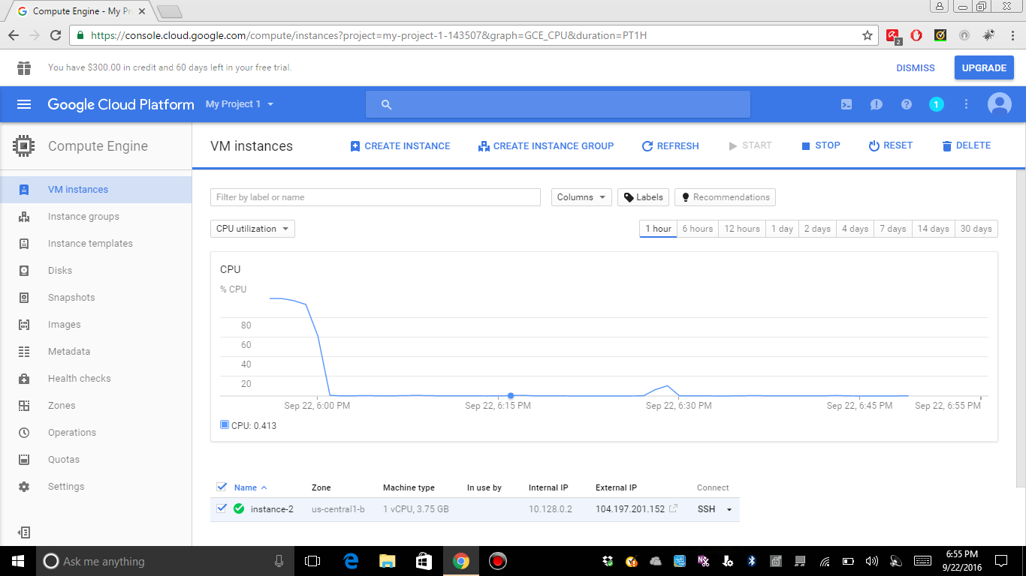

* Open shell
* In vi mode copy paste the content of the script.
* $vi ffmpeg_install.sh

Copy the the content of the file

To save vi mode

:wq!

Change the permission of the script

$chmod 775 ffmpeg_install.sh

Run the script

$sh ffmpege_install.sh

Download google cloud sdk and follow the instruction

<https://cloud.google.com/sdk/gcloud/reference/compute/copy-files>

* In Google SDK use the below command to copy the file from local to cloud instance

gcloud compute copy-files C:\Users\kumar_000\Desktop\SampleVideo_1280x720_1mb.flv leelaparasa@instance-2:/home/leelaparasa/ --zone us-central1-b

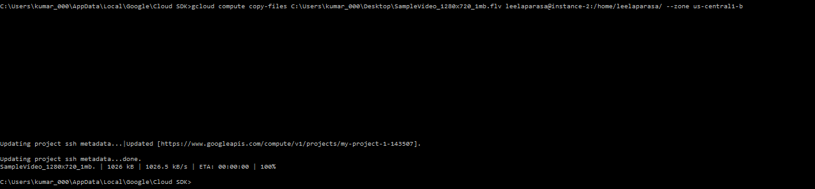

Verify the file in google cloud in ssh.

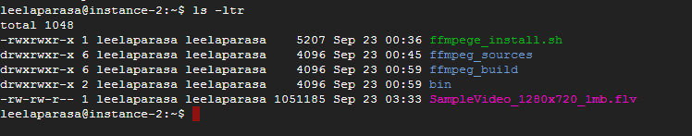

Convert the file:

leelaparasa@instance-2:~$ ffmpeg -i SampleVideo_1280x720_1mb.flv ffmpeg_outbound/sample_converted.webm

verify converted file in outbout directory :

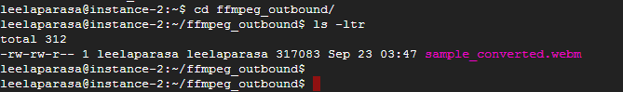

Transfer the file from google cloud to local machine:

open to gcloud sdk

gcloud compute copy-files leelaparasa@instance-2:/home/leelaparasa/ffmpeg_outbound/sample_converted.webm C:\Users\kumar_000\Desktop\

